Watershed Module: Section #6
Section 6: student theories
- Data analysis: What did you learn from sections one through 5?
- Where does climate change fit in?
- What can we do individually and globally?
- Putting it all together: how do we talk about these ideas?

Phenomenon: As I was walking along the beach of Cayuga Lake one day I came across a family looking at a sign posted by the swimming area of the lake park. “My family was planning a fun day at the beach with lots of water-related activities but then we encountered this new sign:” The man said to me.
Sign Text:
CAUTION: HARMFUL ALGAL BLOOMS—Avoid contact with blooms. Keep people and pets away from blooms. Harmful algal blooms have been seen in this waterbody. Blooms can make you and your pets sick. DO NOT EAT FISH CAUGHT IN A BLOOM AREA.

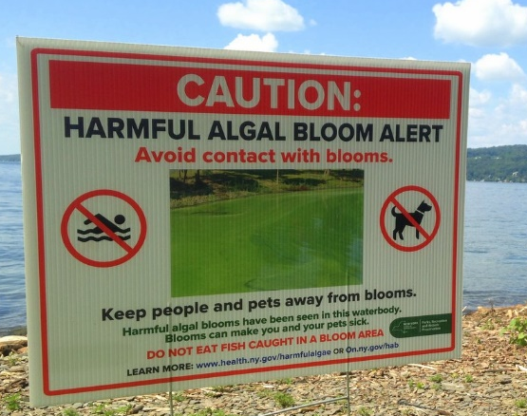
After he read the sign to me, he asked me the following question:
Guiding question: Why are harmful algal blooms (HABs) happening and what can my family do so we can all get in the water again (including our pets.)?

Section 1-5 Conclusions:
In the spaces below write a short summary of what you learned from each of the sections in this module.
Watershed Module: Section #1 Summary:

Watershed Module: Section #2 Summary:

Watershed Module: Section #3 Summary:

Watershed Module: Section #4 Summary:

Watershed Module: Section #5 Summary:

Stewardship and Lake Friendly Living
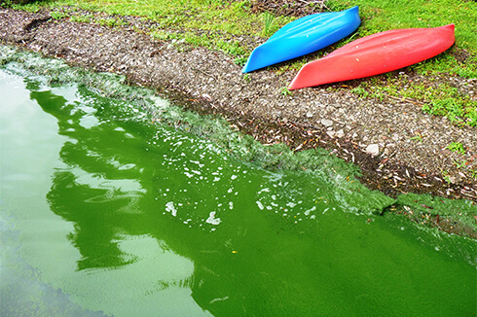
Introduction:
Climate Factors That Affect HABs:
Higher carbon dioxide levels
Algae need carbon dioxide to survive. Higher levels of carbon dioxide in the air and water can lead to rapid growth of algae, especially cyanoHABs that can float to the surface of the water and use the increased carbon dioxide. Increased levels of carbon dioxide also increase the acidity of the water, which affects competition among algal species and impacts the organisms that graze on algae. These effects can combine to increase the competitive advantage of HAB species.
Changes in rainfall and resulting increases in nutrient loadings
Climate change is affecting rainfall patterns, increasing both rainfall intensity and the duration of drought. Increased rainfall causes higher nutrient runoff from land into waterbodies, fueling HABs like those observed in Lake Erie in 2011 and 2015. If followed by extended drought, waterbodies can retain those nutrients for longer, favoring HAB species that compete better under higher nutrient conditions.
Brainstorming activity:
What is one thing we can do individually and one thing we can do globally to address our watershed’s needs short and long term?
INDIVIDUALLY

GLOBALLY
The Lake Friendly Living Program (LFL)
The “First Encounter” Rack Card
Review the rack card below to provide an introduction to the Best Practices you might adopt to protect water quality.
The LFL Pledge:
How will you encourage those at home to help support your pledge?

What questions might you consider to start thinking deeper about taking action?

Visit the CLWN Website to find out more and to register your pledge.
Go to cayugalake.org and click on “Get Involved”
Become a LFL Champion!

Rack Card:
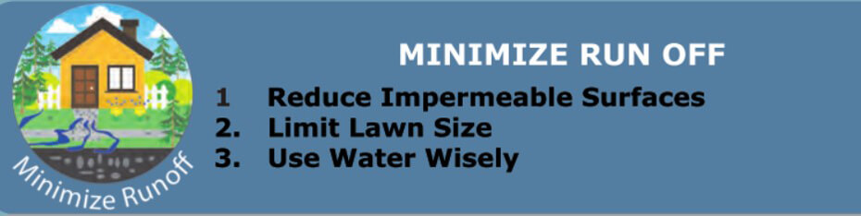
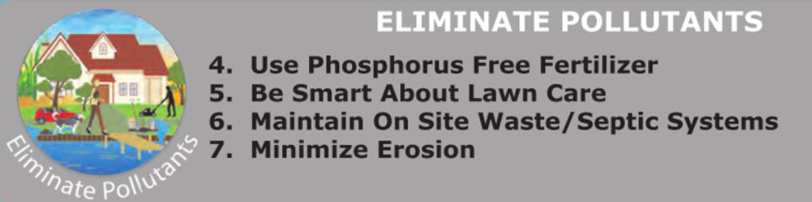
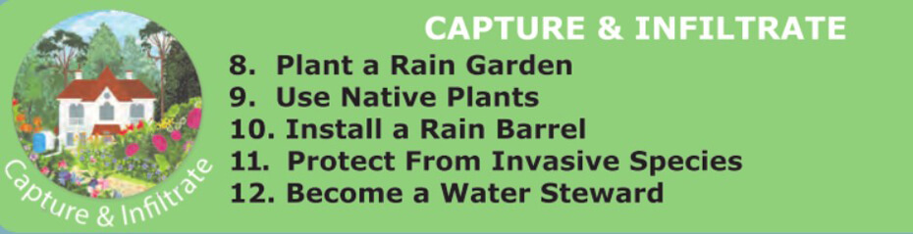
Talking points:
What is something you feel you already do?

What is something you would like to do right now?
Location, location, location!!
Study the Cayuga Lake Watershed Map – where are you located on this map?

Why is it important to know your location in the watershed?

Thinking about water and its impact on my life
Why is water important to me? Why should I care?

What personal experiences do I have with water?

Revisiting the CLWN Website
Lake Friendly Living - Cayuga Lake Watershed Network
Review the Cayuga Lake Homeowners Guide. Use the information to help you decide on a Best Practice to adopt.
Planning for Adopting the Best Practice
Creating your action plan:
- The Best Practice I will adopt is:

- What resources do I already have?

- What resources will I need?

- Where can I find those resources?

- What assistance will I need in order to make my action plan work?

- What are the steps I will follow?

- What is my timeline?

- How will I let others know about my plan?

- How will I know that my plan is successful?

- How will I encourage others to take the pledge?

How can we develop a communications link between us as we move forward?
Questions, Comments…
Thank You!! For your commitment and efforts to preserve, protect, and promote Cayuga Lake water quality.
Nancy and Ed Currier
LFL Liaisons to the CLWN Board of Directors.
ercurrier@aol.com
Important Links:
Air Temperature Data: https://www.nrcc.cornell.edu/wxstation/ithaca/ithaca.html
Surface Water Temperature Data: https://lakemonster.com/lake/NY/Cayuga-Lake-water-temperature-2632
HABs Populations: https://www.database.communityscience.org/hab?utf8=%E2%9C%93&hab%5Bfilter_date_gteq%5D=2018-03-01&hab%5Bfilter_date_lteq%5D=2018-10-31&commit=Filter

YOUR FINAL ASSESSMENT:
Overall summary statement: What will you say to the family at the park?
1. On the Draft sheets provided below write a 1st draft of a script that will explain to the family at the park how HABs would affect their family and their pets if they were to ignore the sign. There should be at least one sentence for each of the included ideas below,
Please include:
- The answer to the Guiding question for this module:
Guiding question: Why are harmful algal blooms (HABs) happening and what can my family do so we can all get in the water again (including our pets.)?

- A definition of HABs:
  - Why are they harmful?
  - What are the harmful algae?
  - Why is a bloom bad for the ecosystem and for them?
- A statement from each of the sections in this module (use the summaries you wrote above in Conclusions of this section to help you}
- A statement that includes three different ways that humans are impacting the growth and population of HABs. These impacts may be all runoff or watershed related, climate change related, or a combination of both.
- Examples of what they could do to support their local environmental organization and what they could do at home to reduce the size and number of harmful algal blooms as individuals.
2. Check the work you have completed on your draft by finding a partner to read your drafts to each other. Alter your draft as necessary and write your change on the draft sheet in the right-hand column using the numbering system described on the sheet. Use the outline above as both rubric and a check list to be sure you have covered the material in the module so the family in the park will understand all they need to know.
3. Once both you and your partner have completed your corrections, write a final draft including the suggestions you came up with and attach it to the draft sheets.

DRAFT SHEET
Write 1st draft on this side of this sheet  and number the corrections as you make  changes with your partner. | Write the correct numbers and the correction for that number on this side of the sheet.
LOCAL RESOURCES:
Cayuga Lake Watershed Network, the Community Science Institute and Discover Cayuga Lake.
Cayuga Lake Watershed Network (CLWN): CLWN maintains communication and collaboration between project partners and the watershed public, including public agencies, concerned residents, and municipalities, online at www.cayugalake.org.
Community Science Institute (CSI): CSI trains volunteers to carry out water quality sampling, provides certified water lab services, presents results via community forums with partners, and publicly shares data, online at www.communityscience.org.
Discover Cayuga Lake (DC), or the Cayuga Lake Floating Classroom: DC maintains a commercial vessel, provides classroom, lake and streamside education programs for students, and offers youth internships and public education programs, online at www.discovercayugalake.org.

