Watershed Module: Section #5
Section 5: harmful algal blooms and climate change
- Research activity: The biology of HABs
- Water quality fact sheet -What is the overall quality of our water?
- Why is it dangerous for you and your pets to go swimming in our lake?
- Where does climate change fit in?

Phenomenon: As I was walking along the beach of Cayuga Lake one day I came across a family looking at a sign posted by the swimming area of the lake park. “My family was planning a fun day at the beach with lots of water-related activities but then we encountered this new sign:” The man said to me.
Sign Text:
CAUTION: HARMFUL ALGAL BLOOMS—Avoid contact with blooms. Keep people and pets away from blooms. Harmful algal blooms have been seen in this waterbody. Blooms can make you and your pets sick. DO NOT EAT FISH CAUGHT IN A BLOOM AREA.

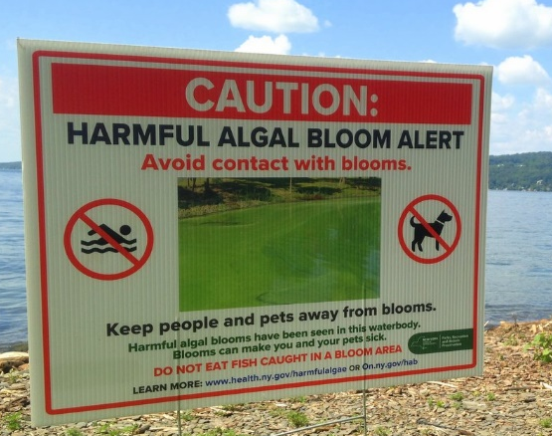
After he read the sign to me, he asked me the following question:
Guiding question: Why are harmful algal blooms (HABs) happening and what can my family do so we can all get in the water again (including our pets.)?

Using what you already know about HABs write your initial answer to the Guiding Question in the space below.

Activity: The Biology of HABs
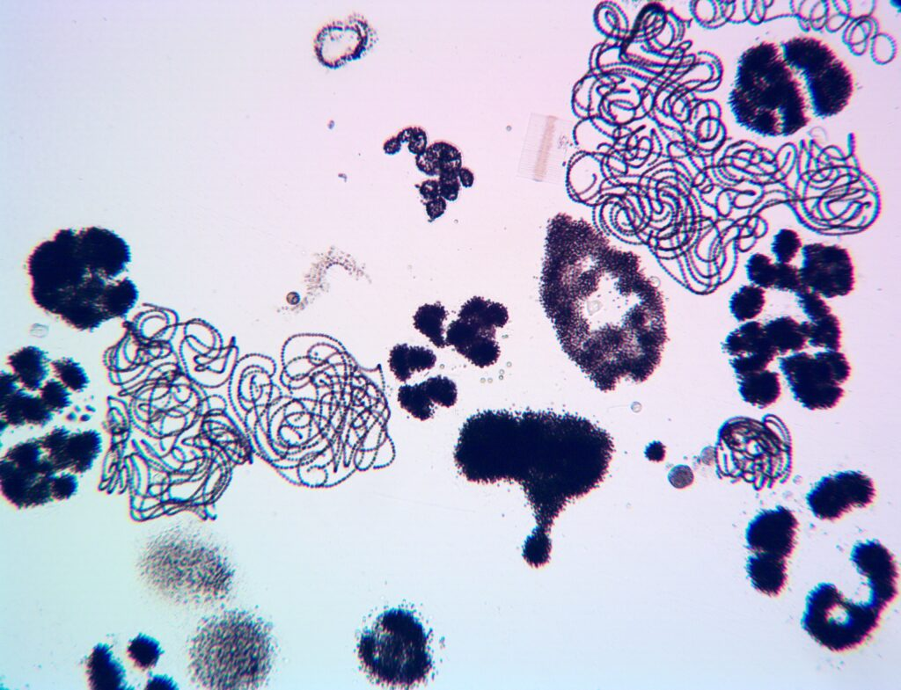
INTRODUCTION: Life of a cyanobacterium.
Phytoplankton, tiny algae that live in the water column, are the base of the food web in bodies of water like lakes and oceans. Phytoplankton can sometimes grow and reproduce very rapidly, forming an algal bloom. During a bloom, so many algae may grow that they change the color of the water.
HABs are Harmful Algal Blooms, or algal blooms that cause harm. Many HABs are caused by dinoflagellates, diatoms, and cyanobacteria, although other types of algae can cause HABs. HABs can deplete water of oxygen and release toxins.
It is important to remember that not all algal blooms produce toxins and not all algal species are harmful. Even algal species that can produce toxins do not always produce toxins. Not all algae are bad for the environment. In fact, all aquatic life depends on them!
Cyanobacteria or blue-green algae often form HABs in fresh water. These HABs are sometimes called cyanoHABs or Harmful Cyanobacterial Blooms (HCBs) and may make the water look blue-green or green. Cyanobacteria can occur as single cells, as thread-like filaments, or as colonies. Some can fix nitrogen, meaning that they can convert nitrogen gas into a biologically useful form, adding nutrients to water. Cyanobacteria can also form blooms in saltwater, for example, in the Great Salt Lake in Utah, U.S.A., and the Baltic Sea.
Life cycle: Cyanobacteria – Harmful Algal Blooms
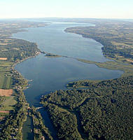
On the boat: The Biology of HABs:
Data collection:
The Floating Classroom
Cayuga Lake Watershed

Investigator____________________________Date___________
Location:_____________________________________________
Time__________Group Members__________________________
Site ______ water depth_____________
Cloud cover __________ Weather conditions ________
Wave Height __________ Secchi reading ________
Wave frequency __________ Current speed /direction ________
Wind speed/direction __________ Air Temperature ________
Description of weather conditions over the last 24 hours:

Depth
Location
Secchi Depth
Conditions:

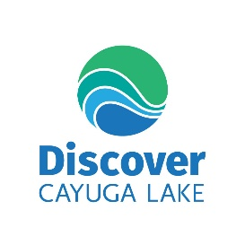
PLANKTON SURVEY
(Circle each organism you observe.)

Phytoplankton (Plant-like, autotrophic)
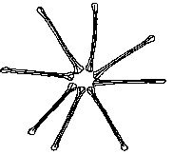
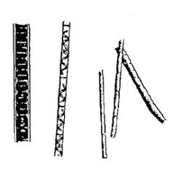
1. GREEN ALGAE 2. BLUE-GREEN Algae 3. YELLOW-BROWN (Diatoms)
Dolichospermum
Asterionella
Filamentous Spp.
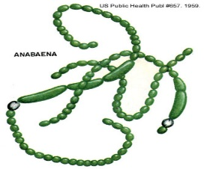

Spirulina

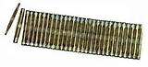
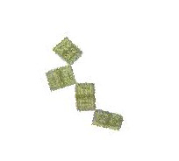
Fragillaria
Tabellaria
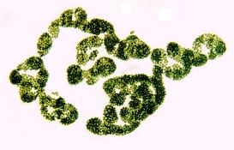
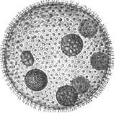

Microcystis
Volvox
Pediastrum

Phytoplankton
Name | Diagram/description | Relative number | Additional comments

Zooplankton (Kingdom Animalia, heterotrophic)
- ”Waterfleas” (phylum ARTHROPODA, subphylum CRUSTACEA…)
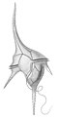
- Class MAXILLOPODA (sub-class COPEPODA) Class Dinophyceae
Ceratium
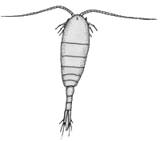
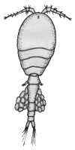
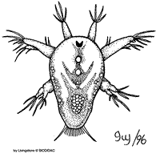
Calanoid
Cyclopoid
Nauplius (larval stage)
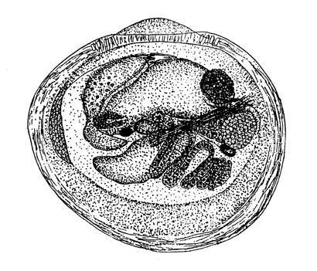
INVASIVE LOOK-ALIKES

Zebra Mussel Larvae (veliger)
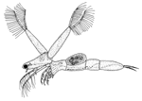
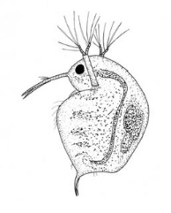
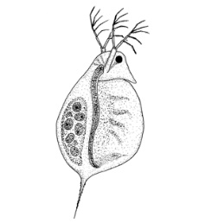

Class BRANCHIOPODA, order CLADOCERA)
Leptadora
Bosmina
Fishhook Water
Flea (Cercopagis)

Daphnia

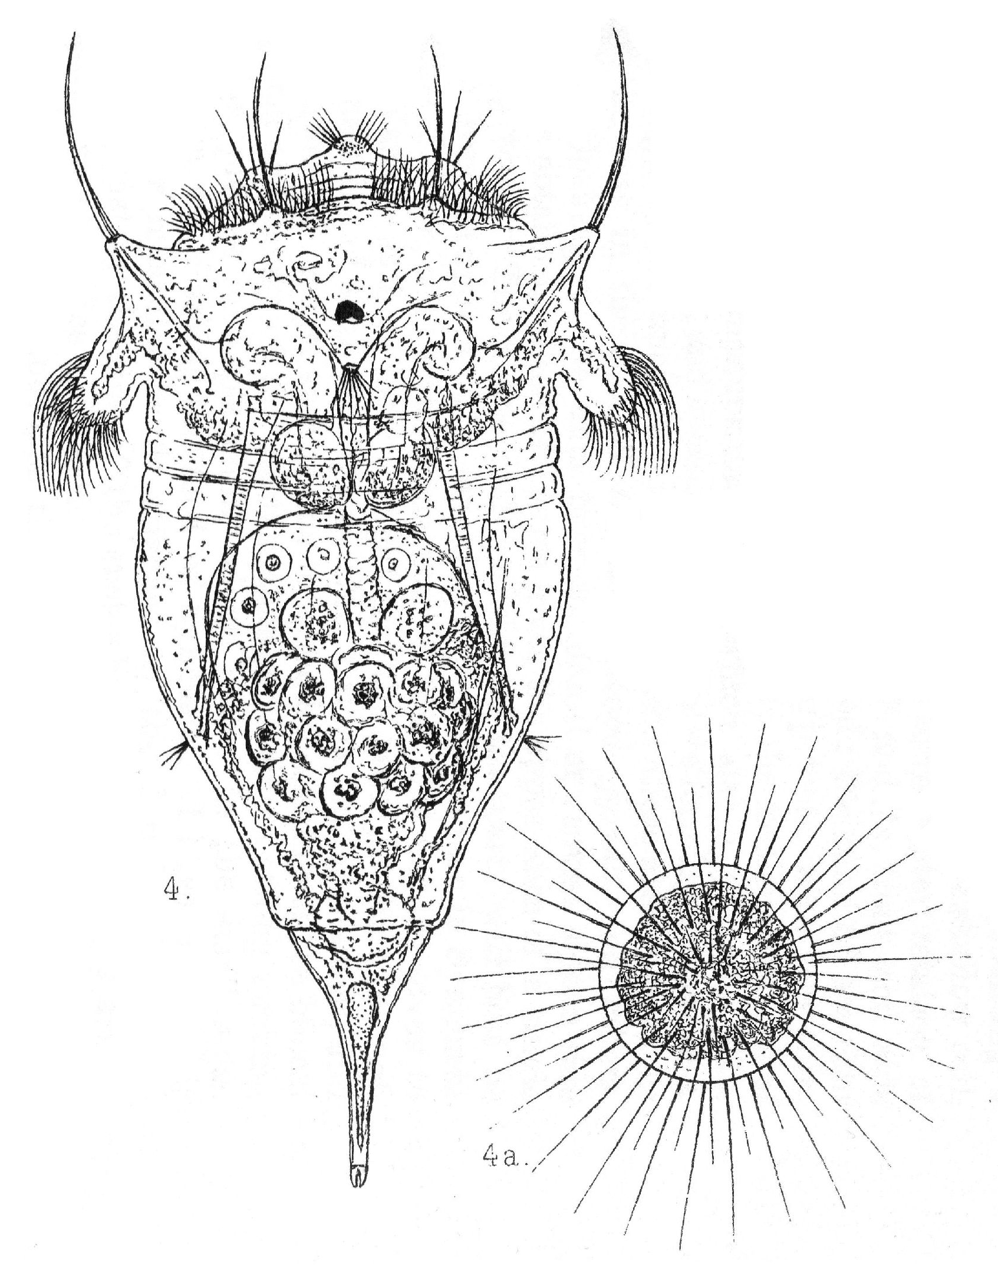

2. “Rotifers” (phylum ROTIFERA….)
Synchaeta (w/egg)
Keratella
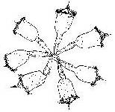
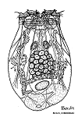
Asplanchna

Conochilis
(lives in colonies)

(

Zooplankton
Name | Diagram/description | Relative number | Additional comments

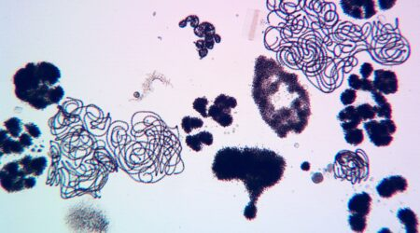
Notes: HABs Biology
What are they?

What populations are found in Cayuga Lake?

What makes them harmful?

What factors affect population size?

Activity: What is going into our lake?
INTRODUCTION:
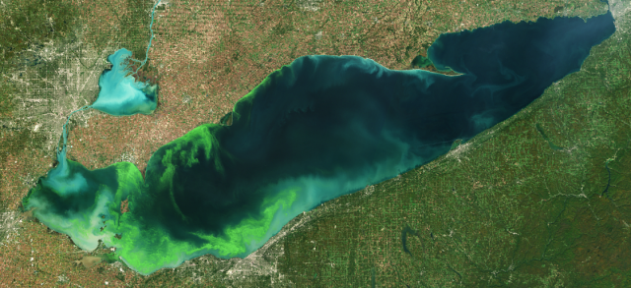
Changes in rainfall and resulting increases in nutrient loadings
A satellite image of a cyanoHAB -taken on October 8, 2022- in the western basin of Lake Erie. (Image credit: European Space Agency)
Climate change is affecting rainfall patterns, increasing both rainfall intensity and the duration of drought. Increased rainfall causes higher nutrient runoff from land into waterbodies, fueling HABs like those observed in Lake Erie in 2011 and 2015. If followed by extended drought, waterbodies can retain those nutrients for longer, favoring HAB species that compete better under higher nutrient conditions.
Moreover, increases in extreme rainfall and subsequent increases in freshwater flows may flush large loads of nutrients, freshwater HABs and their associated toxins into estuaries and marine areas. As a result, estuarine and marine waters may be at greater risk of developing HABs or seeing an exacerbation of existing HABs.
PART 1: INDICATORS OF WATER QUALITY
PROCEDURE:
- Go to the website below and read over the introduction for the information sheets and explain what analytes are in the space below:
Learning Materials | Community Science Institute
- As you look over the page you will see that in order to determine water quality several analytes must be measured and analyzed. For the purpose of this activity you will be concentrating on three of the indicators that have an impact on HABs population size: dissolved oxygen, phosphorus, and organic nitrogen.
- Return to the webpage above and use the links found on that page to answer the questions in the boxes below:
Dissolved Oxygen (click on the link to the right under the fish)
WHAT IS IT?

HOW DOES IT GET IN THE WATER?

HOW DOES IT INTERACT WITH AQUATIC ORGANISMS?

HOW IS IT MEASURED?

Total Kjeldahl nitrogen (TKN)
WHAT IS IT?

HOW DOES IT GET IN THE WATER?

HOW DOES IT INTERACT WITH AQUATIC ORGANISMS?

HOW IS IT MEASURED?

Phosphorous
WHAT IS IT?

HOW DOES IT GET IN THE WATER?

HOW DOES IT INTERACT WITH AQUATIC ORGANISMS?

HOW IS IT MEASURED?

- Try one more-pick any of the other analytes and use the information sheets to answer the question in the box below:
The analyte I chose is __________________________
WHAT IS IT?

HOW DOES IT GET IN THE WATER?

HOW DOES IT INTERACT WITH AQUATIC ORGANISMS?

HOW IS IT MEASURED?

WILL THIS FACTOR IMPACT HABS?

PART 2: HUMAN IMAPACT AND RUNOFF
PRODEDURE:
- Now we are ready to look at the actual data. The link below will take you to the data sets on the CSI website.
Community Science Institute Database

- The data sets you will need for this activity are in the Lake Chemistry section

Click on the “explore map” button on the “Streams and Lakes Chemistry” tile and read over the key to help you understand what each of the colored pins represent.
Set the map on Satellite view by clicking the button in the top left of the map. Try zooming in and out to get a feel for how the map works. Click on an individual pin to isolate that data set and move in close.

- In this part of this activity, you will be looking at the possible impacts humans could be making on the chemistry of the lake by looking at the facilities around where the data was collected and speculating what impact they may have. You will also concentrate on Cayuga Lake so click on the “Cayuga Lake Watershed” link and when the image loads be sure to click the “satellite” button again.

- Working in groups of four, each person chooses one of the four areas listed in the table below. Place a star next to the area you chose – that is your area of the lake to explore! You will record the information for the other areas on the tables as the other members of your group present that information to you.

- Click on the link to the lake area you chose-don’t forget to return the map to satellite view. Fill in your section of the table below by listing three of the facilities (like a residential area or a farm) or land areas (such as a roadway or a landfill). Using the information you have gathered in Part 1 of this activity and other sections of this Module, speculate on the chemical impact of the facilities you listed by placing a YES OR NO in the analyte on the rest of your row of the table. Don’t forget to include the analyte you chose in Part 1.

Lake Area | Facility list  (NAME OF AREA THAT WILL AFFECT THE WATERSHED | Organic nitrogen  (YES OR NO) | Ammonia  (YES OR NO) | Phosphorus  (YES OR NO) | The other analyte you chose ______  (YES OR NO)
Cayuga Heights Streams | 1.  2. | 1.  2.  3. | 1.  2.  3. | 1.  2.  3. | 1.  2.  3.
Cayuga Lake East Shore | 1.  2.  3. | 1.  2.  3. | 1.  2.  3. | 1.  2.  3. | 1.  2.  3.
Cayuga Lake West Shore | 1.  2.  3. | 1.  2.  3. | 1.  2.  3. | 1.  2.  3. | 1.  2.  3.
Cayuga Lake West Shore | 1.  2.  3. | 1.  2.  3. | 1.  2.  3. | 1.  2.  3. | 1.  2.  3.

- Choose a person in your group to present first and then go around to each member of the group until you have recorded all of your group’s information in the above table.
ANALYSIS
In the space below create a four to 5 sentence summary statement that includes a sentence that explains how each of the explored areas in the table above impact Cayuga lake. Also include a final statement that describes how this overall impact could affect HABs growth.

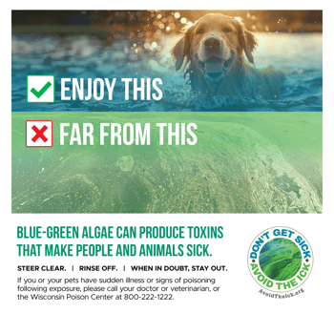
Activity: Why are HABs harmful to pets?
QUICK READ:
Cyanobacteria, a type of microalgae, are ancient photosynthetic freshwater prokaryotic organisms found worldwide. These organisms can proliferate in a body of water under specific environmental conditions, such as warm water temperatures and availability of phosphorus and nitrogen. These proliferations are termed harmful algal blooms (HABs).
At least 95 cyanobacteria species have the potential to produce toxins, and cyanobacterial toxicosis has been documented in humans, companion animals, livestock, and wildlife. Cyanobacteria produce several types of toxins that can cause clinical diseases including respiratory, gastrointestinal, dermatological, and neurologic disease. In some circumstances, they can result in sudden death.

Cyanobacterial toxins:
- Hepatotoxins
cylindrospermopsin, microcystins, nodularins
These toxins damage the liver, leading to depression, loss of appetite, vomiting, diarrhea, abdominal tenderness, and jaundice minutes to days after exposure.
- Neurotoxins
anatoxins, guanitoxin (formerly called anatoxin-a(s)), saxitoxins
Anatoxins are nicotinic agonists. Guanitoxin is a cholinesterase inhibitor that cannot cross the blood-brain barrier, and saxitoxins block sodium channels. Each of these toxins disrupts nerve cell communications, and they can lead to respiratory paralysis. Many cases of neurotoxin ingestion result in death within one hour.
- Dermatotoxins
aplysiatoxin, lyngbyatoxin-a
These cause irritation to the skin and can irritate the respiratory airways if inhaled. This leads to coughing and wheezing.

Quick video:
How to protect your dog from Harmful Algal Blooms
YouTube·Cornell University·Jun 18, 2026

Summary:
1, In the space below, use the types of toxins defined above to explain what could happen to your pet if they are exposed to HABs. Underline the types of toxins in your answer.

  - Find a partner and read the summary you wrote above and have them answer the following question in the space provided.
Why is it important to keep my dog away from harmful algal blooms?

What do you think so far… Look over your notes and the data you collected during this section and use this information to answer the “so far” questions below.
Section 3:  Watersheds | Explain what it is: | Explain how it could be related to the phenomenon:
HABs SPECIFIC
ORGANISMS

Types of toxins produced by HABs

Analytes

Section 5 Glossary:
Add the underlined terms found in the text Section 5 and complete the table below
Term | Illustration/key word | definition

