Watershed Module: Section #4
Section 4: harmful algal blooms on Cayuga lake
- History of harmful algal blooms –mapping activity
- A history of climate change in New York
- Climate change and HABs

Phenomenon: As I was walking along the beach of Cayuga Lake one day I came across a family looking at a sign posted by the swimming area of the lake park. “My family was planning a fun day at the beach with lots of water-related activities but then we encountered this new sign:” The man said to me.
Sign Text:
CAUTION: HARMFUL ALGAL BLOOMS—Avoid contact with blooms. Keep people and pets away from blooms. Harmful algal blooms have been seen in this waterbody. Blooms can make you and your pets sick. DO NOT EAT FISH CAUGHT IN A BLOOM AREA.

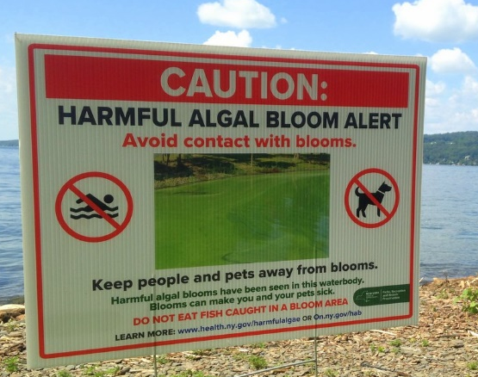
After he read the sign to me, he asked me the following question:
Guiding question: Why are harmful algal blooms (HABs) happening and what can my family do so we can all get in the water again (including our pets.)?

Using what you already know about HABs write you initial answer to the Guiding Question is the space below.

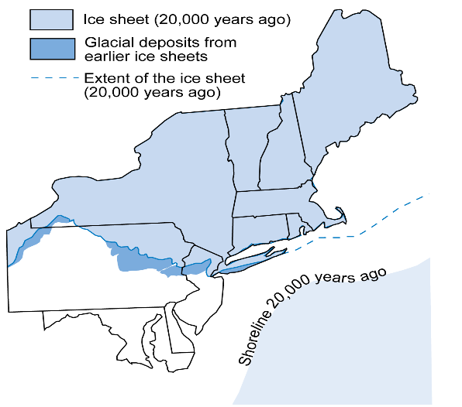
Activity: The Formation of The Finger lakes
INTRODUCTION:
The Great Lakes
A mere 20,000 years ago, the Great Lakes did not exist. At that time, the ice sheets extended well past where the lakes would now occur. The Great Lakes were actually river valleys that were scoured and deepened repeatedly by the numerous ice advances during the Quaternary period. As the glacier retreated and the basins filled with glacial runoff, the still-forming lakes drained southward, eventually into the Mississippi River.
The broad, deep basins of Lakes Ontario and Erie, former river valleys, were scooped out by tongues of ice as the glacier advanced over North America. When the glacier began its retreat, meltwater flooded lake basins. Lakes Ontario and Erie were both much larger than today. Glacial meltwater poured into these basins, and the ice blocked drainage that would eventually flow to the northeast via the St. Lawrence River. The Erie and Ontario Lowlands, as well as the once-flooded Mohawk River Valley south of the Adirondacks, are the remains of the much larger lakes. Flat, lowland topography and characteristic lake bottom sediments are found in the areas where the lakes once reached.

The Finger Lakes
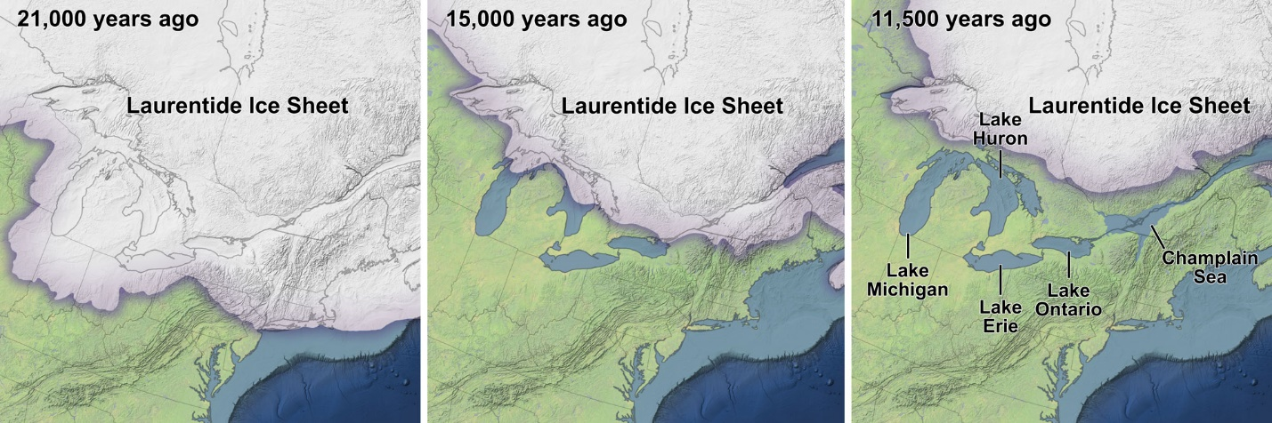
The Finger Lakes were pre-existing river valleys before the tongues of ice covered the area and widened and deepened the valleys. The stream valleys were dammed at their southern end by glacial till and flooded to form the Finger Lakes when the ice sheet retreated. Whereas streams only erode as far down as sea level, glaciers are able to erode more deeply. The bottoms of two of the Finger Lakes (Lakes Seneca and Cayuga) are actually below sea level.
Part 1: Shaping the landscape.
- Click on the link below and watch the short video all the way through taking mental note of the general concept that is presented:
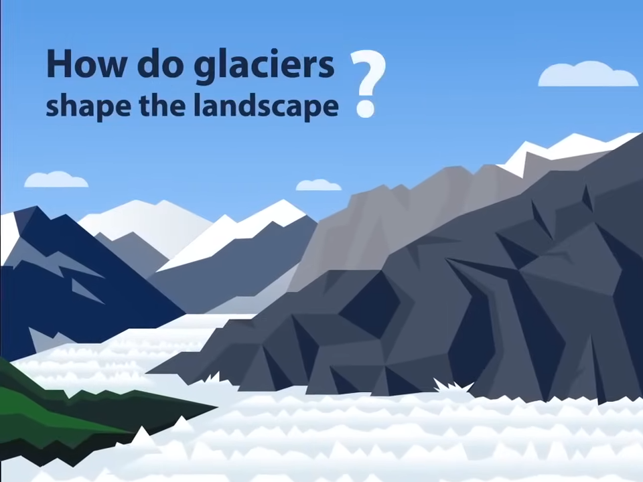
https://youtu.be/loI584OFVpE
2. Watch the video a second time pausing if needed to answer the following questions:
a. What are the three ways that glaciers shape the landscape?

b. How are each of the following terms related to how glaciers shape the landscape?
-erosion
-freeze-thaw weathering
-plucking
-abrasion
-deposition
-glacial till

c. Include the definition of these terms in the Glossary at the end of this section of the module.

Part 2: Modeling Glacial Retreat and its Effects on the Landscape
Materials for each group:
-water
-ice cubes
-sand
-twigs and small sticks
-rock salt
-various sizes of stones (pebbles and small rocks-some with points)
-spray bottles
-aluminum tray (like you would make a turkey in)
-9in. by 9in. aluminum tray or pan (something that can be frozen)
-ridged tray or cutting board (to transfer the 9in. by 9in. pan into the freezer-it will be full of water)
-a book about an inch thick. (this book may get wet so you may want to substitute a piece of wood)

PROCEDURE
- The purpose of your model is to demonstrate as many of the terms you defined in Part 1 by modeling the three ways in which glaciers change the landscape. (take a quick look back at Part 1 if you do not remember these three ways)
This section will take overnight to freeze:
- Start by making the glacier. In the bottom of the 9in. by 9in. pan, place the various sizes of pebbles and small stones along with a small amount of sand. Slowly put water in the pan – leave some space at the top so it can be transferred to a freezer. Place the tray in the freezer overnight.
- Making the landscape. Place about 2 inches of sand at the bottom of the larger aluminum tray and smooth it out. Place the small sticks, twigs and more stones over the surface of the sand-you can stand some of the larger twigs up in the sand if you like to represent trees.
- Obtain three ice cubes and bury them some random places around the edge of the tray to represent ice that broke away from the glacier. We will revisit them later after they have melted.
- Retrieve the now frozen glacier from the freezer and carefully pop it out of the pan and place it on the tray next to your group’s landscape, with the stone side down.
- First the glacier will advance. Place a small book under one end of the landscape (a book about an inch thick. Place your glacier as close to the middle of the same edge of the large tray as the book. Push the edge of the glacier away from the book about a half inch or so into the sand. (see image below).

SIDE VIEW
GLACIER
LANDSCAPE

BOOK
BURIED ICE CUBE

TOP VIEW

- Push the glacier forward in the landscape four or five inches-try to keep the glacier at the same depth in the landscape. Using the images below to help you diagram and label what happens to the landscape on the table below. (this step has been completed for you as an example.)

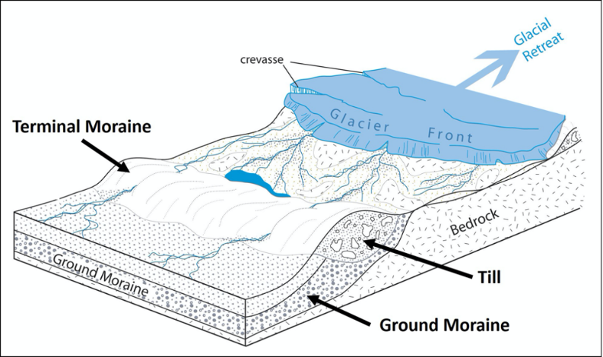
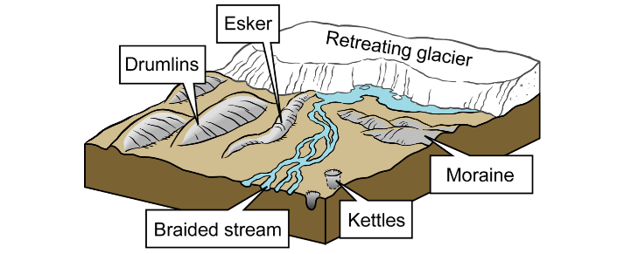
- To represent the glacier receding, use the rock salt and the spay bottles (try on stream and mist for comparison) and begin to melt the glacier. Stop the melting process every few minutes to record a new description and draw a new labelled diagram. Use the additional images below to help with the labels. Try melting from different angles and locations – remember the ice does not melt in one spot at a time. Continue this process until the glacier is almost completely melted or receded.

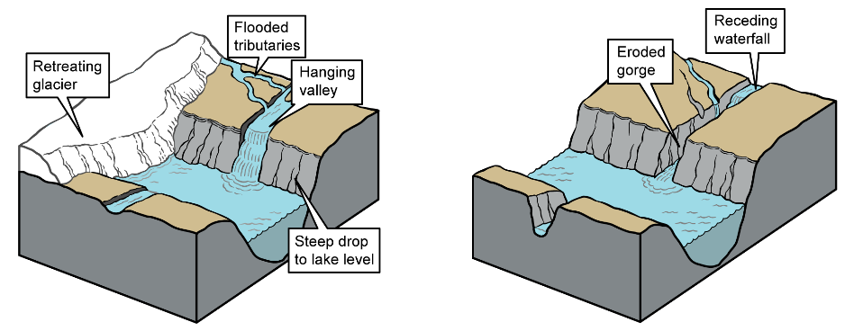
DIAGRAM | DESCRIPTION | NUMBERED TERMS
From #7 1  2 3 | The landscape is built up in front of the glacier and along the sides. There are scratches and high and low spots behind the glacier. | 1, glacier  2. till  3. terminal moraine
From # 9

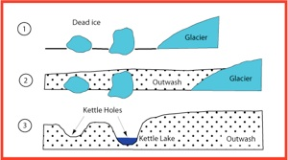
- Look back at the places where you buried the ice cube. Remember these represented small pieces of the glacier that broke off and were buried as the glacier receded. Notice that where the ice cube melted there is a small hole. Use the diagram to the right to help you describe and draw a labelled diagram of these spots on the table above where it is marked “from # 9”.
Analysis and Group Comparison
Presented Information | Group 1 | Group 2
List of labelled terms
3 things the same as your model | 1.  2.  3. | 1.  2.  3.
3 things that are different from your model | 1.  2.  3. | 1.  2.  3.

Activity: Climate Change and the Finger Lakes
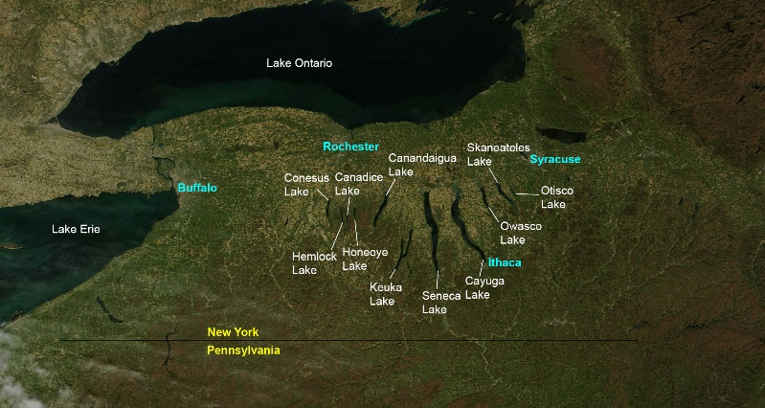
The Finger Lakes originated as a series of northward-flowing rivers that existed in what is now central New York State (today central New York south of Ithaca drains to the south, toward the Chesapeake Bay, while the rest drains north and east to the St. Lawrence Seaway). Around two million years ago the first continental glaciers moved southward from the Hudson Bay area, initiating the Pleistocene glaciation, commonly known as the Ice Age. The Ice Age was really a series of many advances of glaciers (one approximately every 100,000 years). The advances are called glacials, and the retreats are called interglacials. Today we live during an interglacial.
The Finger Lakes were probably carved by several of these episodes. Ice sheets more than 2 miles (3 kilometers) thick flowed southward, parallel but opposite to the flow of the rivers, gouging deep trenches into these river valleys. Traces of most of the earlier glacial events have been eroded away, but much evidence remains of the last one or two glacials that covered New York.
The latest glacial episode was most extensive around 21,000 years ago, when glaciers covered almost the entire state. Around 19,000 years ago, the climate began to warm, and the glaciers began to retreat, disappearing entirely from New York most recently around 11,000 years ago.
One obvious bit of evidence left by the glaciers are the gravel deposits at the southern ends of the Finger Lakes, called moraines, which are piles of rock pushed along the edge of the advancing glacier.

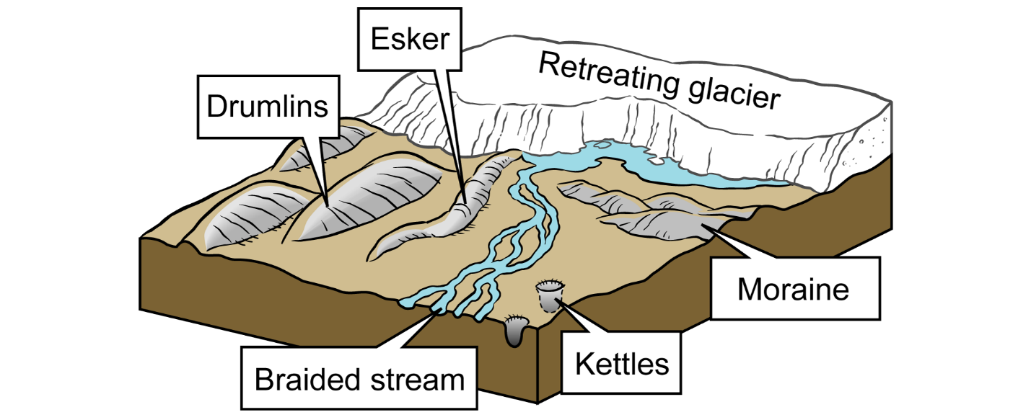
Examples of different types of glacial features. Image modified from original by J. Houghton first published in The Teacher-Friendly Guide to the Geology of the Northeastern U.S. by Jane Ansley (published by the Paleontological Research Institution) (CC BY-NC-SA 4.0 license).
Scavenger Hunt: Using the following link define the terms above in the table below.
Link: https://earthathome.org/finger-lakes-geology/geology-finger-lakes/
TERM | DESCRIPTION | DRAWING/COLOR KEY
ESKER |  | YELLOW
DRUMLINS |  | GREEN
BRAIDED STREAM |  | LIGHT BLUE
KETTLES |  | DARK BLUE
MORAINE |  | TAN

Below is an image from the Finger Lakes. Together with a partner try to find examples of each of the terms you described above and color them in; use the color key given in the table above.
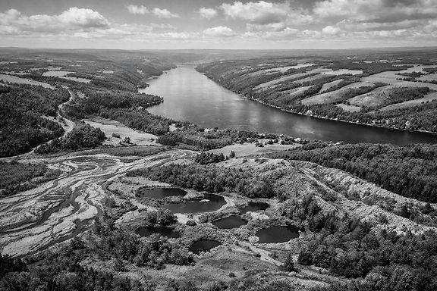
Once you are finished labeling and coloring, compare your image with 2 other groups and record 3 similarities and three differences you find with that group record them in the table below.
Presented Information | Group 1 | Group 2
3 things the same as your model | 1.  2.  3. | 1.  2.  3.
3 things that are different from your model | 1.  2.  3.

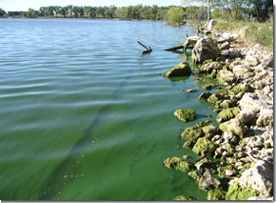
Activity: Climate Change and Harmful Algal Blooms (HABs)-Data Analysis
INTRODUCTION:
Climate Factors That Affect HABs:
Warming water temperature
HAB-forming cyanobacteria thrive in warm, slow-moving water, and typically occur when water temperatures are warmer. As a result, increases in water temperature with climate change are expected to to increase the magnitude and duration of cyanoHABs. Warmer water temperatures favor cyanoHABs in several ways, including:
- CyanoHAB species grow faster than other algae at warmer temperatures
- CyanoHABs migrate up and down the water column better than other algae. They get nutrients from the cooler, dark, bottom layers and use them to grow in the warmer, upper layers where there is more light. Other algae cannot do this and are shaded by the CyanoHAB species.
- CyanoHABs absorb sunlight and release heat, making surface waters even warmer, further increasing their advantages.

LET’S LOOK AT THE DATA
While examining the data sets that follow keep the following question in mind:
Can we say: warmer air temperature = warmer surface water temperature = greater population of harmful algae?

Air Temperature Data:
PROCEDURE:
- Use the following link to complete the data table below.
NRCC The Ithaca Climate Page
- Scroll to the section labelled “ Annual Summaries”. Working together with your partner (s) change the field in the date box in the “ Annual Temperature Summary Graph” section to 2010 and click on “ GET SUMMARY.
- 2010 HAS BEEN DONE FOR YOU AS AN EXAMPLE
- Record the information from the graph on Table 1 remembering to:
- Record only the months of March through September
- Use a plus sign before the number to indicate above the norm (red on the graph) and a minus sign to indicate below the norm (blue on the graph).
- Record for each of the years from 2011to 2025 in the same way as the example by changing the date box year accordingly
Table 1: Air temperature change Cayuga Lake from 2010-2025 during the months of March until September
YEAR | MARCH | APRIL | MAY | JUNE | JULY | AUGUST | SEPTEMBER
2010 | +5.8 | +5.6 | +3.6 | +1.6 | +2.6 | +1.6 | +0.9
2011
2012
2013
2014
2015
2016
2017
2018
2019
2020
2021
2022
2023
2024
2025

CONCLUSIONS
What are two statements that you can make about this data set?
!.

2.

Surface Water Temperature Data:
PROCEDURE:
- Use the following link to complete the data table below.
Cayuga Lake water temperature Water Temperature & Fishing Reports | LakeMonster
- Scroll to the graph labelled “Temperature Trends.” Working together with your partner (s) change the field in the graph to “All Time “by clicking on the ALL-TIME BUTTON.
- You will find the first data point (represented on this graph (July 1st, 2018) by placing the curser over the far-left portion of the line on the graph. What is the Surface water temperature for the first point recorded in July of 2018? ____________degrees F.
- By slowly moving the curser to the right, record the information from the graph on Table 2 remembering to:
- Record the date in the first and the last month that the temperature is above 60 degrees F.
- Color in the column to create a bar graph on the table with the first and the last day above 60 degrees F. labeled to indicate the range. NOTE: EACH BOX REPRESENTS AN FULL MONTH. (see 2018 example).
- You will find the months or 2018 has been done for you as an example.
- Continue for each year until the last data point above 60 degrees F. in 2025.

Table 2: Surface Water Temperature above 60 Degrees F each year from July 2018 to September 2025.
MONTH | 2018 | 2019 | 2020 | 2021 | 2022 | 2023 | 2024 | 2025
March
April
May
June
July | 1st |  | 1st  14th
August
September

October | 14th
CONCLUSIONS:
What are two statements that you can make about this data set?
!.

2.

Harmful Algal Blooms Data INTENSITY COLORS KEY
Confirmed Bloom: Applied to a HAB report received from the public or a trained HABs Harrier volunteer that CSI staff determine—based on digital photographs or a descriptive field report—is a cyanobacteria bloom; OR a HAB report and sample submitted to CSI pending microscopy and/or laboratory analysis.
Confirmed Bloom: Cyanobacteria are present in the HAB sample. Microscopic examination indicates the presence of cyanobacteria and therefore the potential for the HAB to be harmful. Laboratory analysis including chlorophyll-a and microcystin results pending.
Confirmed HAB: Cyanobacteria dominated HAB with a microcystin toxin concentration less than the drinking water limit (0.3 µg/L).
Confirmed HAB: Cyanobacteria dominated HAB with a microcystin toxin concentration in between the drinking water limit (0.3 µg/L) and the limit for contact recreation (4.0 µg/L).
Confirmed HAB: Cyanobacteria dominated HAB with a microcystin toxin concentration that exceeds the limit for contact recreation (4.0 µg/ L).
PROCEDURE:
- Use the following link to complete the data table below.
Community Science Institute Database
- As you look at the HABs data your goal will be to generate a map for each of the seasons (each year between 3/01 and 10/31. NOTE: the information in table 3 for the first season during 2018 has been done for you as an example.
- Go to the data set at the above Community Science Institute (CSI) website.
- Check to see that the time range boxes are set for the first season (2018 3-01 to 10-31) If it is not set to that season click on the blue FILTER button and then type 2018 3-01 in the first box and then 2018 10-31 in the second box.
- Click on the blue FILTER button and the data for that year will appear. Find the number of HABs events for that year and record the number in Table 3.—see example.
- Look at the intensity colors key provided above (it is also below the map on the data page) to understand what each of the colored pins on the map of Cayuga Lake represent. NOTE: movement on the map and zooming in and out requires 2 fingers to accomplish.
- Count the number of each colored pin and record the number in the appropriate column in Table 3. See 2018 season on the table as an example. Answer the following questions in COMMENTS in table 3.
  - Did you get the same numbers?
  - What intensity was the highest?
  - Where was it the least?
  - Where on the lake are the blooms for this season the worst?
- Change the season date in the buttons to next year and push the blue FILTER button again. Repeat the steps outlined in numbers 5-7 for each of the years listed on Table 3 and answer questions b., c., and d., in number 7 for each year.
Table 3: HABs Event number and Intensity
SEASON | # HABs  EVENTS | # | # | # | # | # | COMMENTS
2018  3-01 TO 10-31 | 46 | 5 | 4 | 8 | 1 | 15
2019
3-01 TO 10-31
2020
3-01 TO 10-31
2021
3-01 TO 10-31
2022
3-01 TO 10-31
2023
3-01 TO 10-31
2024
3-01 TO 10-31
2025
3-01 TO 10-31

CONCLUSIONS:
What are two statements that you can make about this data set?
!.

2.

ANALYSIS QUESTIONS:
Trends and Connections:
A second look at the activity question:
Can we say: warmer air temperature = warmer surface water temperature = greater population of harmful algae?
Using the conclusions you made after examining each data set, complete the Analysis Table below:
Analysis Table:
DATA SET | ONE TREND IN THIS DATA | CONNECTION BETWEEN THIS DATA SET AND ONE OTHER DATA SET | CONNECTION BETWEEN THIS DATA SET AND BOTH OF THE OTHER DATA SETS
AIR TEMPERATURE
WATER TEMPERATURE
HABs POPULATION

- Briefly describe three factors that affect the population size of HABs.

- In this activity you looked at the relationship between surface water temperature and HABs population size, briefly describe another relationship that could also be examined.

Overall summary statement:
Using the Analysis Table information write a short narrative that would explain to the family at the park how rising air temperatures could affect the population of HABs in a way that would make the water conditions unsafe for swimming.

What do you think so far… Look over your notes and the data you collected during this section and use this information to answer the “so far” questions below.
Section 3:  Watersheds | Explain what it is: | Explain how it could be related to the phenomenon:
Toxins

Climate Change

Essential nutrients

Section 4 Glossary:
Add the underlined terms found in the text of Section 4 and complete the table below
Term | Illustration/key word | definition

Notes

