Watershed Module: Section #3
Section 3: Nutrient loading—the algal bloom cascade.
a. Nutrient sources—point and nonpoint source pollution
b. Design project: building a watershed
c. What makes the bloom happen?

Phenomenon: As I was walking along the beach of Cayuga Lake one day I came across a family looking at a sign posted by the swimming area of the lake park. “My family was planning a fun day at the beach with lots of water-related activities but then we encountered this new sign:” The man said to me.
Sign Text:
CAUTION: HARMFUL ALGAL BLOOMS—Avoid contact with blooms. Keep people and pets away from blooms. Harmful algal blooms have been seen in this waterbody. Blooms can make you and your pets sick. DO NOT EAT FISH CAUGHT IN A BLOOM AREA.

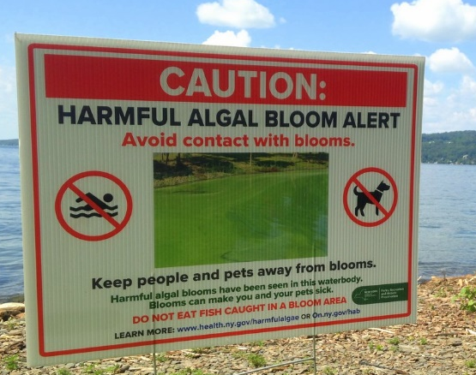
After he read the sign to me, he asked me the following question:
Guiding question: Why are harmful algal blooms (HABs) happening and what can my family do so we can all get in the water again (including our pets.)?

Using what you already know about HABs write you initial answer to the Guiding Question is the space below.

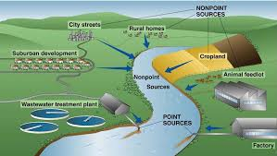
Activity: Point and Non-point Source Pollution Match Game
INTRODUCTION
What makes point and nonpoint source pollution different from each other?
Point Source Pollution
Point source pollution is defined as coming from a single point, such as a factory or sewage treatment plant. Here are a few examples of point source pollution OR&R worked on. Deepwater Horizon oil spill, Gulf of Mexico — Releasing about 134 million gallons of oil the 2010 Deepwater Horizon oil spill is the largest point source of oil pollution in United States history. Mosaic Acidic Water Release, Florida — On Sept. 5, 2004, acidic water was released during Hurricane Frances from Mosaic Fertilizer, LLC’s storage containment system. The spill polluted nearly 10 acres of seagrass beds and more than 135 acres of wetland habitats, including almost 80 acres of mangroves. Montrose Hazardous Releases, California — From the late 1940s to the early 1970s, millions of pounds of DDT and polychlorinated biphenyl were discharged into ocean waters off the southern California coast. Most of the DDT originated from the Montrose Chemical Corporation manufacturing plant located in Torrance, California. In 2001, NOAA and other federal and state agencies reached a settlement with the polluters, establishing the Montrose Settlements Restoration Program (MSRP).
Non-Point Solution Pollution
Runoff from urban and suburban areas is a major origin of non-point source pollution. Discarded trash can become a component of non-point source pollution runoff. For the last 10 years, NOAA’s Marine Debris Program has been tackling non-point pollution of marine debris by leading research, prevention, and removal projects. Here are a few examples of non-point source pollution the Marine Debris Program worked on. Tijuana River, California — The large amounts of trash and larger debris that wash downstream threaten and degrade the Tijuana River Valley’s valuable ecological, cultural, recreational, and economic resources. A grant from NOAA funds work that includes the removal and disposal of debris that accumulates behind large trash booms designed to block debris from flowing into the ocean. Shuyak Island, Alaska — With the support of a Marine Debris Program grant, the Island Trails Network (ITN) is leading an innovative two-year effort to remove marine debris from a remote island in Alaska. Working with 100 volunteers and trained crew, ITN created a kayak-based cleanup operation to remove about 40,000 pounds of marine debris from Shuyak Island. The island — a remote location with critical habitat for numerous species of birds, fish, and marine mammals — accumulates large amounts of marine debris because of ocean currents and winds. Joe Inslee is a policy/outreach analyst with NOAA’s Assessment and Restoration Division. His work helps raise the visibility of the critical scientific work his office conducts after a hazardous release.
Use the article you read in the introduction to define these two terms:
- Pollution—

- Point source pollution—

- Non-point source pollution—

MATCH GAME
Label each of the following images with “P” for point source pollution and “NP” for non-point source pollution.
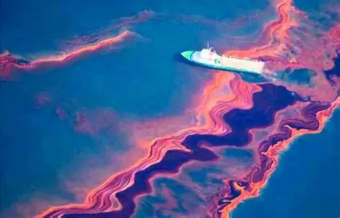

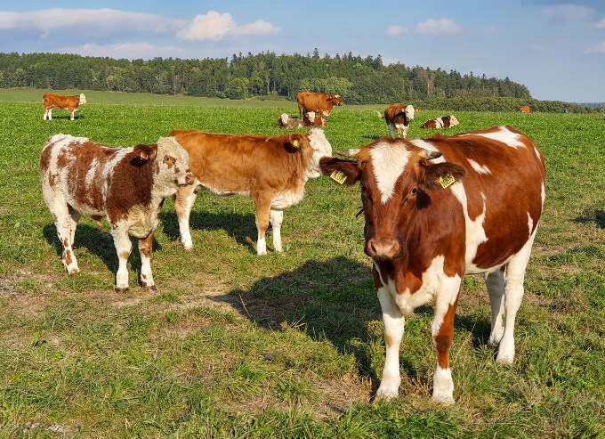
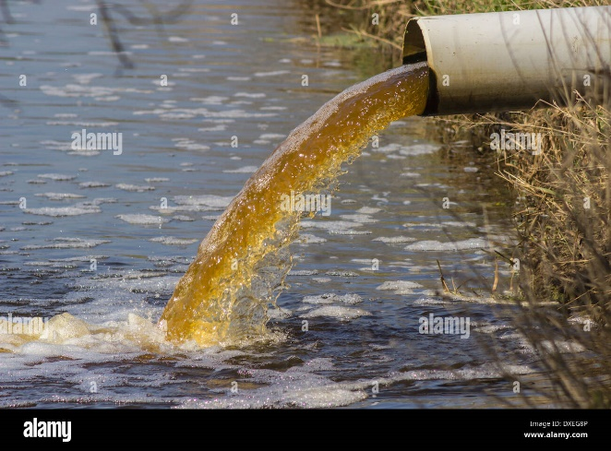

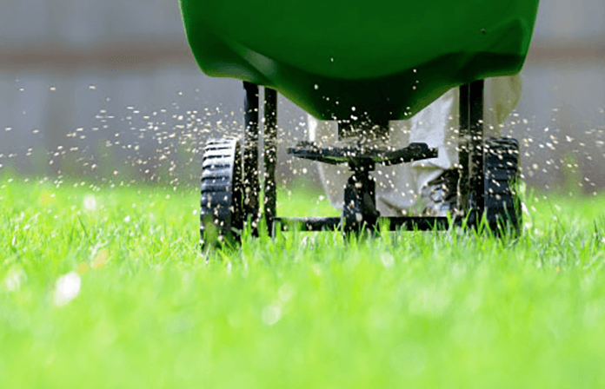
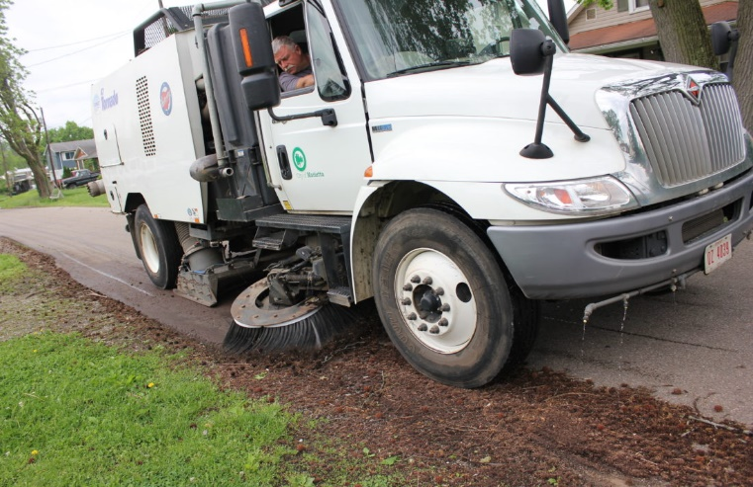
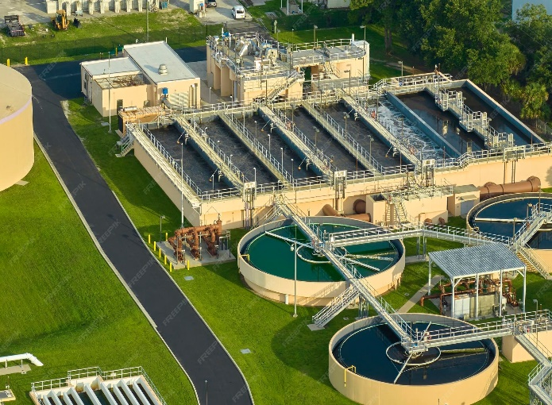
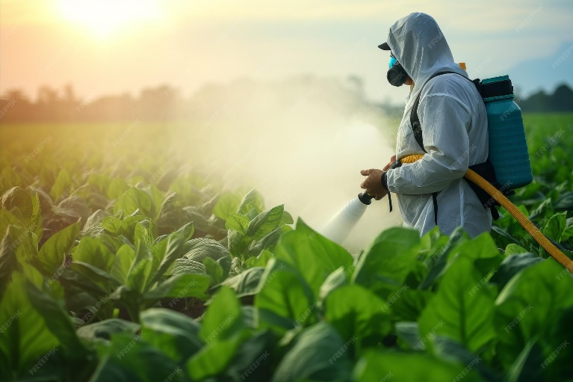
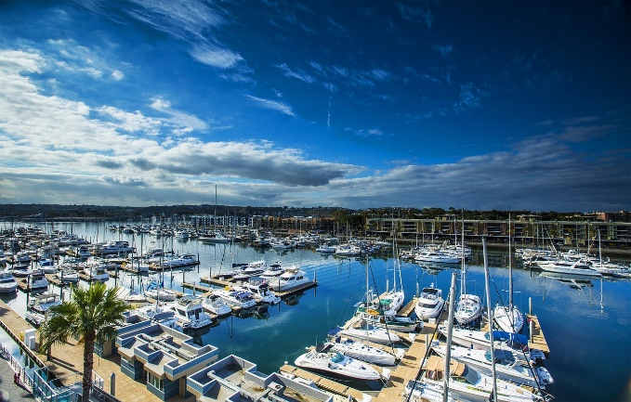
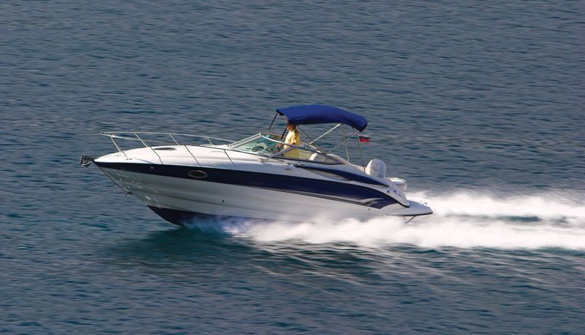

ANALYSIS
- Did you discover any sources that may be considered both?
- Whish of these sources of water pollution do you think may cause an algal bloom and why?
- Why is it much harder to remediate pollution that is non-point source?

Activity: Paper Watershed Landscape
INTRODUCTION:
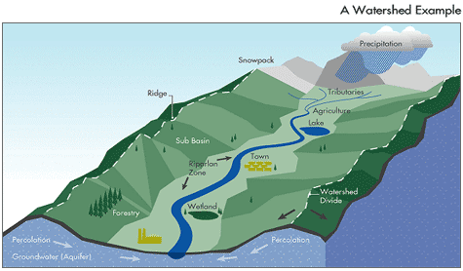

Courtesy of University of Nebraska, Lincoln Extension
This lesson also available as a pdf
Background Information:
In this activity, you can make a watershed model. Remember, a watershed is all the land that “sheds” water from rain and snowmelt into a specific stream, river or lake. The boundaries of a watershed are the mountains, hills, or other high points where land slopes toward the water. Watersheds can be very small or very large. A large watershed may have many smaller watersheds. It’s like the branches of a tree. The tiny twigs join bigger twigs, the bigger twigs join larger branches, and the branches join the trunk. Small streams flow into larger streams, larger streams flow into rivers, and rivers flow into larger rivers or even gulfs, seas and oceans.
Materials:
- 2 sheets of paper, 8 1/2 x 11 inches. Use paper from the recycling bin.
- A spray bottle filled with water.
- Non–permanent markers so the colors will run when moistened. You’ll need blue, brown, green, and red. Or substitute another color if needed.
- A tray or lots of old newspapers or towels to catch water
Instructions:
- Take one sheet of paper and crumple it up in your hands.
- Then open up the paper, but do not flatten it. You want it to have some “relief” – some high and low places. The high places are hills, the low spots are valleys, the wrinkles are streams and rivers.
- With a blue marker, draw on the paper where you think the streams and rivers would be.
- Check to see if you are right. Place the paper on a tray or newspapers or towels. With the spray bottle, make it rain in the watershed. Squirt a fine mist over the watershed model, enough to make water flow down the “hills”. Did you draw the streams and rivers in the right places? Do you have a lake? This is how watersheds function, the water is shed by the land into streams, rivers, and lakes.
- Now do the same thing with the second piece of paper, crumple it, then open it up but not too much.
- Draw the streams and rivers with the blue marker. Maybe include a lake or two.
- Next, use a brown marker and draw along the tops of the hills. With a green marker you can draw in trees, grass, crop or pasture land. Use a red marker to draw towns, houses or businesses.
- Place the “watershed” on a tray or newspapers or towels and squirt it with water. You’ll see streams again. But you’ll now see a lot of other stuff (colors) running into the streams along with the water. If this were a real watershed, the brown could be dirt from bare soil,
the green could be grass clippings or leaves, and the red could be oil from leaky cars or fertilizer someone spilled on a driveway. That’s what happens when things on the ground are picked up by stormwater runoff, they end up in streams and rivers and moving down the
watershed.
- Be sure to clean up when you are finished with your watershed models.
Discussion Questions:
- What are examples of small watersheds in your neighborhood?
- What stream, river or lake does the runoff water from your neighborhood empty into?
- Why do pollution problems tend to get worse farther downstream?
- What is the name of the watershed you live in?
- What are some ways you can help keep your own watershed clean and help watersheds downstream?

Activity: HYDRO LOGIC TOWN PLAN
INTRODUCTION
What is a watershed?
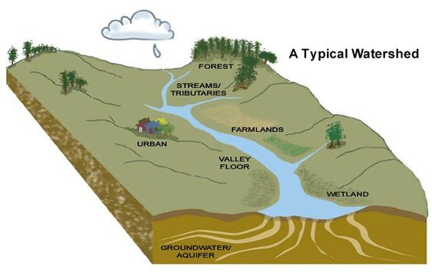
A watershed is an area of land that channels precipitation, such as rain and snowmelt, into a common body of water. Watersheds can vary in size, from small watersheds like a single county or inland lake to large watersheds that cover many smaller watersheds. For example, the Mississippi River has a huge watershed that covers parts of 33 states. A watershed is also known as a drainage basin or catchment. The geography of a watershed directs where water goes. For example, a bathroom sink works like a watershed, with water flowing from the high points of the sink to the lowest point, the drain.
Watersheds affect the water quality of the body of water they surround. All land drains into a body of water, so the condition of watersheds is important to everyone.
What is runoff?
In a watershed, "runoff" refers to the portion of precipitation (rain or snowmelt) that doesn't soak into the ground but instead flows across the land surface, eventually reaching streams, rivers, or other bodies of water within that watershed; essentially, it's the water that moves over the land instead of infiltrating the soil.
Why is it important to understand nutrient loading?
Understanding nutrient loading is crucial because excessive nutrients entering an aquatic ecosystem, often from human activities like agriculture and wastewater discharge, can lead to significant environmental problems like harmful algal blooms, oxygen depletion, and disruption of aquatic life, ultimately impacting water quality and the health of the entire ecosystem; therefore, comprehending this process is key to identifying and mitigating these environmental issues. Excess nutrients, primarily nitrogen and phosphorus, stimulate rapid plant and algae growth, causing a phenomenon called eutrophication. These large-scale algal growths can block sunlight penetration, reducing oxygen levels in the water, harming fish and other aquatic organisms. Severe cases of nutrient loading can create areas with extremely low oxygen levels, known as "dead zones," where most aquatic life cannot survive. Disruption of the natural balance in an ecosystem due to nutrient loading can lead to shifts in species composition, impacting the entire food web.
Now that you have read through the introduction to this activity, answer the beginning understanding questions below
Beginning Understanding Questions:
What is a watershed?

What is runoff?

Why is it important to understand nutrient loading?

RESEARCHING YOUR FACILITY
My assigned facility is:_________________________Place a star next to your assigned facility.
- Complete Table 1 below to research the facility you were assigned.
Table 1: Resources
FACILITY | USE YOUR A.I. RESOURSE TO HELP YOU RESEARCH THE QUESTIONS BELOW | RESEARCH FINDINGS
Walmart/Lowes Plaza  -2 Stores and Parking  -truck access | How can a shopping plaza affect a watershed?
Sanitary Landfill  -2 access roads (one for trucks and one for the public) | How can a sanitary landfill affect a watershed?
Gun Hill Factory-Store front and parking | How can a factory affect a watershed?
Waste Water Treatment Plant  Handles gray water and sewage-truck access | How can a wastewater treatment plant affect a watershed?
Dairy farm  Pastureland for livestock  land for growing feed | How can agriculture affect a watershed?
Town Residences  -2 Neighborhoods  -1 apartment complex | How can town residences affect a watershed?
Parks and Recreation  3 State Parks  1 marina with dock  space | How can a state park and marinas affect a watershed?
Small businesses  parking and access to public and trucks | How can a small businesses and parking lots affect a watershed?

- After your group researched your assigned facility:
- Fill in your section on the “Other Facility Information” Table 2 below:
- Take turns with the other groups presenting the information you collected during your research. You will only be presenting the information for the first two columns in Table 2 (pollutants and Problems).
- Fill in the rest of Table 2 with the information the other groups presented.

Table 2: Other Facility Information
Place a star next to your assigned facility.
- Using the information, you gathered from the resources above fill in your assigned facility.
- Fill in the rest of this table by listening to the presentations from the other student groups. Each group will only be presenting the Pollutants and Problems columns.
- Brainstorm some ideas for placement of your facility as well as the others presented and fill in the last column.

Facility | Pollutants | Problems | Ideas for placement
Walmart/Lowes Plaza
-2 Stores and Parking
-truck access

Sanitary Landfill
-2 access roads (one for trucks and one for the public)

Gun Hill Factory
-Store front and parking

Waste Water Treatment Plant
Handles gray water and sewage-truck access
Dairy farm
Pasture land for livestock
land for growing feed

Town Residences
-2 Neighborhoods
-1 apartment complex

Parks and Recreation
1 State Park
1 marina with dock
space

Small businesses
parking and access to public and trucks

Building your Watershed
Rain cup
Materials:
-aluminum tray
-aluminum foil (1.5 times the length of the tray)
Landscape
- 6 cotton balls
-2 plastic cups (one with holes and one without)
-facilities sheet
Aluminum tray
-string
-6 toothpicks
-food coloring
-water
-scissors
-hot glue gun
Procedure
- Obtain materials listed above.
- Follow directions given by instructor to “fold” the foil and place it in the aluminum tray so it looks similar to the image above creating a three-dimensional landscape inside the tray.
- Considering the possible impact of your assigned facility, place it in the landscape you just created. Later in this activity you will be presenting to the other groups why you placed this facility where you did so record your reasoning in the space below to guide you through the presentation.

PRESENTATION NOTES FOR YOUR ASSIGNED FACILITY

- Once you have decided on the location, use the hot glue to attach your assigned facility to the landscape.

- With the rest of your group, create a plan for the placement of the remaining facilities to create a small town. Record the reasoning for the placement of each of these facilities in the space provided below.

REASONING FOR ADDITIONAL FACILITIES

- Once your group has decided on the placement of the remaining facilities, use the glue gun to attach the remaining facilities to the landscape.
- For this model, the string represents roads, the cotton represents vegetation, and the toothpicks represent docks. Together with the other members of your group, decide where to place these items in your landscape-you may cut any of these items into smaller pieces if you like. Your group will be asked to explain why you made these changes to your landscape. Record the reasoning for these changes in space below.

REASONING FOR CHANGES MADE TO THE LANDSCAPE

PRESENTATIONS: WHAT IS YOUR HYDROLOGIC TOWN PLAN?
Preparations:
- Read over the Response Sheet and decide in your groups which person will present what part of the response sheet to the other groups.
- Fill in the Preparation sheet below with your part of the presentation using the information you gathered above.

PREPARATION SHEET
The reasoning for placement of this group’s assigned facility.

The measures this group has taken to protect the environment.

A brief description of the overall Hydrotown Plan.

List the changes your group made to the watershed and why?

PRESENTATION PROCEDURE:
- Each group will take turns using their landscape as a visual aid and explaining the reasoning of their town design.
- When presenting, each group member will take turns presenting the portion of the preparation sheet they chose to present.
- While each group is presenting the other groups will be recording the presenters reasoning on the response sheet.
- After all the groups have completed their presentations, it will be time to test their designs during The Spill.

THE SPILL
- Obtain two plastic cups. The cup with the holes in the bottom is the “rain cup” and the one without holes is the “fill cup”.
- Starting with the first group that presented, your instructor will create a spill, and a member of the group will rain on your landscape.
- To “create a spill” the members of the group will first decide what that spill might be if it come from the facility they were assigned. Then the instructor will place 2 drops of that group’s food coloring near their assigned facility.
- To “rain“on the landscape one member will fill the fill cup with water and on the count of three, when everyone is ready, hold the rcup over the landscape and pour the water in the fill cup into the rain cup while slowly moving both cups together over the landscape until the “rain” stops.
- Take note of what happens to the spill to help in the decision of who had the best design after all groups have had a spill.

Response Sheet
Presenters assigned facility: _______________________
The reasoning for placement of this group’s assigned facility.

The measures this group has taken to protect the environment.

A brief description of the overall Hydrotown Plan.

The changes this group made to the watershed and why?

Presenters assigned facility: _______________________
The reasoning for placement of this group’s assigned facility.

The measures this group has taken to protect the environment.

A brief description of the overall Hydrotown Plan.

The changes this group made to the watershed and why?

Presenters assigned facility: _______________________
The reasoning for placement of this group’s assigned facility.

The measures this group has taken to protect the environment.

A brief description of the overall Hydrotown Plan.

The changes this group made to the watershed and why?

So, which one was the best?
What were three things the group that you feel did the best did very well during their presentation?
1.

2.

3.

What are three areas the group that you feel did the best protected the water ways from runoff from their facility?
1.

2.

3.

Write a short statement explaining why the group you think did the best job was the best.
The “Best” Town plan was… …and this is why?

FACILITIES SHEET

Hospital

Recycle Center

Shopping Plaza
Walmart/Lowes

Hydro Power Plant

School

Lumber Company

State Park with Marina

Town Hall

Gun hill factory

Bank

Waste Water Treatment Plant

Sanitary Land fill

Fire Station

Salt mine

Dairy Farm

livestock field

HOUSE
HOUSE

Barn

Crop field
HOUSE
HOUSE
HOUSE
HOUSE

Car wash
HOUSE
HOUSE

Laundry/dry cleaner

Garden Apartments

Gas Station

Food Stand

Activity: What makes algal blooms—bloom?
INTRODUCTION
What is nutrient loading?
Nutrient loading is the excessive introduction of nutrients—primarily nitrogen and phosphorus—into aquatic ecosystems, largely driven by human activities like agricultural runoff, wastewater, and fertilizer use. It causes severe environmental harm, including harmful algal blooms (HABs), oxygen depletion (hypoxia), and "dead zones" that kill fish and disrupt aquatic life.
Some research:
Get together with a partner and research the following questions: (be sure that both partners record the answers to both of these questions in the space below).
  - What are three of the main nutrients that algae need to survive and how do they use them?
  - What are two ways each of these nutrients could enter our lake?

A look at our lake…

What do you think so far… Look over your notes and the data you collected during this section and use this information to answer the “so far” questions below.
Section 3:  Watersheds | Explain what it is: | Explain how it could be related to the phenomenon:
Point and non-point source pollution

Nutrient loading

Watershed

Section 3 Glossary:
Add the underlined terms found in the text Section 3 and complete the table below
Term | Illustration/key word | definition

Notes

