Watershed Module: Harmful Algal Blooms (HABs) and the Cayuga Lake Watershed
Watershed Module: Section #2
Section 2: Plankton in the lake
- Collection: Plankton - What is a plankton tow?
- Collection Equipment
- Phytoplankton vs. zooplankton

Phenomenon: As I was walking along the beach of Cayuga Lake one day, I came across a family looking at a sign posted by the swimming area of the lake park. The Father said “My family was planning a fun day at the beach with lots of water-related activities. Then we encountered this new sign:”
Sign Text:
CAUTION: HARMFUL ALGAL BLOOM ALERT—Avoid contact with blooms. Keep people and pets away from blooms. Harmful algal blooms have been seen in this waterbody. Blooms can make you and your pets sick. DO NOT EAT FISH CAUGHT IN A BLOOM AREA.

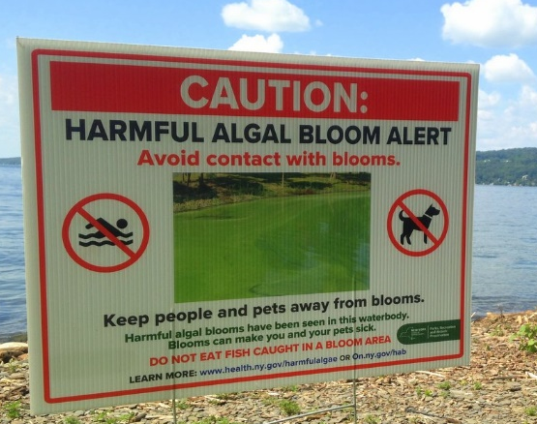
After he read the sign to me, he asked me the following question:
Guiding question: Why are harmful algal blooms (HABs) happening and what can my family do so we can all get in the water again (including our pets)?

Activity: Descriptive Writing and Illustration
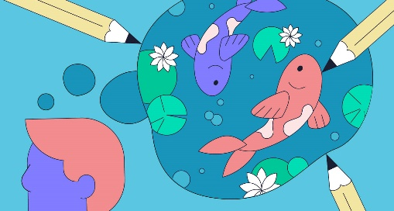
- In the box on the left below, describe the organism you have been assigned. You may not use the organism’s name or where it lives in your description.
- Return your object to the front of the room and trade papers with someone else.
- Using the description, you received, try to find the exact object the other student described.
- In the box on the right below, draw a diagram of the organism that was originally yours. Try to do this only using your original description. Once you have tried, go ahead and retrieve your original object and finish your illustration.

Description Illustration

- Get together with your partner one more time and share with each other what words in your description helped them find your object. List the descriptors that helped your partner find your object in the space below:

- Use the words you listed above to label your illustration - use at least three of these descriptors.

Guiding question: Why are harmful algal blooms (HABs) happening and what can my family do so we can all get in the water again (including our pets)?

Activity: A video survey of Environmental Testing equipment - Deployment and uses
INTRODUCTION
Why is Limnology Important?
Limnology is important because it provides crucial knowledge about the functioning of freshwater ecosystems like lakes, rivers, and wetlands, allowing us to effectively manage water resources, protect biodiversity, monitor pollution levels, and understand the impacts of climate change on these vital environments, ultimately contributing to human well-being and sustainable water use.
The videos below describe many of the ways field scientists gather information in aquatic systems. Watch each of these short videos and complete the activity that follows.

Plankton Tow
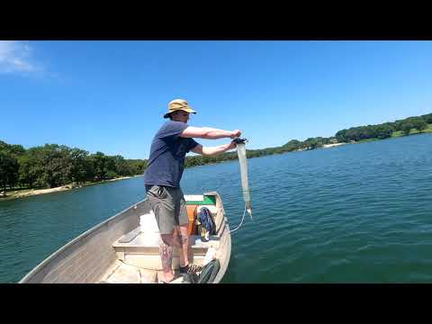

Video link (YouTube): https://youtu.be/-PlN-8Zqr98

Secchi Desk

Video link (YouTube): https://youtu.be/9j4EgKvo7Bw

Vertical water sampler
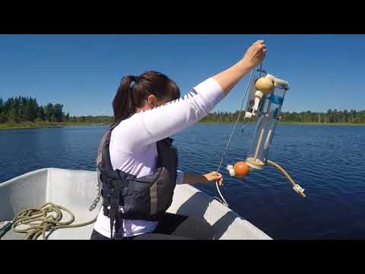
Video link (YouTube): https://youtu.be/TNPXjwm_0Kw
Bottom grab
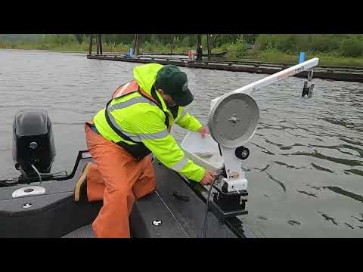
Video link (YouTube): https://youtu.be/jYHvvmxZ2Zk

Watch and present:
- Find a partner and each of you pick 1 or 2 videos to explain to your group/partner.
- Watch your two videos taking notes on how to deploy (use) the devices you picked.
- Using your notes, teach your partner how to deploy the devices you chose.
- Switch and have your partner teach you the other two.
- Answer the “use” questions below together.
Use Questions:
- Which device would you use to measure water clarity (turbidity)?

- Which device would you use to look at the sediment at the bottom of a lake?

- Which device would you use to collect water to measure dissolved oxygen levels?

- Which device would you use to look for invasive species at the bottom of the lake?

- Which device would you use to collect zooplankton?

- Which device would you use to determine how much algae is in the water column?
Guiding question: Why are harmful algal blooms (HABs) happening and what can my family do so we can all get in the water again (including our pets)?

Activity: Phytoplankton vs. Zooplankton
INTRODUCTION
Why are plankton important to an aquatic ecosystem?
Plankton are crucial to an aquatic ecosystem because they act as the foundation of the food web, providing a primary food source for a vast array of marine life, from small fish to whales, by producing their own food through photosynthesis, and also play a significant role in regulating the global carbon cycle by absorbing carbon dioxide and producing oxygen.
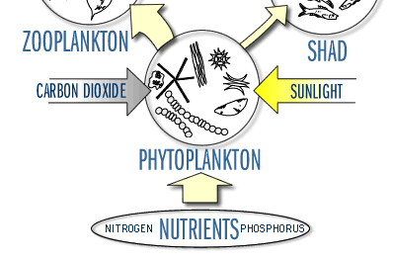
Where are the plankton?
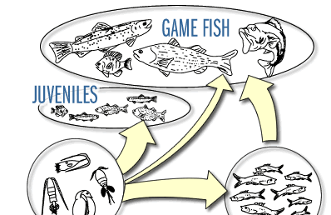
Using the diagram above and the knowledge of food webs you gained by completing the activities in Section 1, work with your classmates to complete the following flow chart (Concept map).

Utilize nutrients such as

Use energy from
Collect CO2 from the

and

Are
Consumed by

WORD BANK
PHYTOPLANKTON
ZOOPLANKTON
ATMOSPHERE
SUNLIGHT
NITROGEN
PHOSPHATE
GAME FISH
JUVENILES
SHAD
Provide energy for adult
Pass their energy to energy

and
Who then grow to become

Utilizing the concept map you completed above, write three sentences that briefly describe the functions of the two groups of plankton in the above food web.
1.

2.

3.

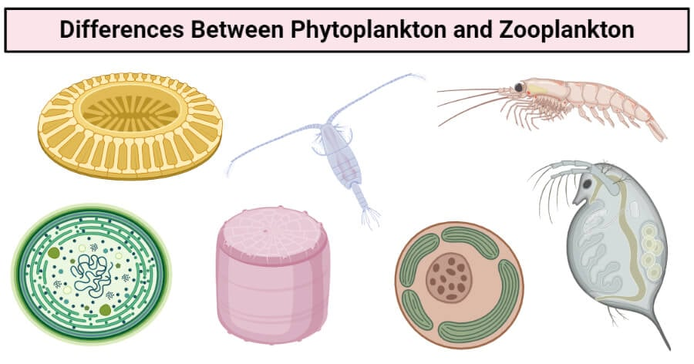
Comparing zooplankton and phytoplankton
1
2
3
4
5
6
7

Which of the above belongs to the phytoplankton group? #_____________________________

Which of the above belongs to the zooplankton group? #_____________________________

Characteristics of Plankton Presentation

PROCEDURE:
- Choose one of the groups of plankton from the table above
- Find a partner who specializes in the other group of plankton.
- Using the information table above create an informational mini poster to use as a visual aid as you are presenting your group of plankton to your partner.
- You may create your own format but be sure to include the following in your poster:
- An informative title.
- At least 2 images that represent your group of plankton.
- With images or text represent each of the topics in the first column of the information table above.

Activity: Collecting Data

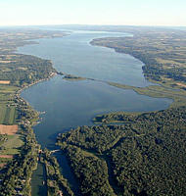
The Floating Classroom
Cayuga Lake Watershed

Investigator____________________________Date___________

Location:_____________________________________________
Time__________Group Members__________________________
Site ______ Depth_____________

Phytoplankton
Name Diagram /Description relative number

Zooplankton
Name Diagram/Description relative number

Organisms found in bottom grab
Name Diagram/Description relative number

Chemical Analysis
Location:_____________________________________________
Time__________Group Members__________________________
Site ______ Depth_____________
Bottom Depth_______
Water color____________
Temperature _______
Dissolved oxygen_______
Nitrogen _______
Carbon Dioxide _______
PH _______
Phosphate _______

Midway Depth_______
Water color____________
Temperature _______
Dissolved oxygen_______
Nitrogen _______
Carbon Dioxide _______
PH _______
Phosphate _______

Surface Depth_______
Water color____________
Temperature _______
Dissolved oxygen_______
Nitrogen _______
Carbon Dioxide _______
PH _______
Phosphate _______

Physical characteristics
Location:_____________________________________________
Time__________Group Members__________________________
Site ______ Depth_____________

Bottom Grab

Section diagram (label sediment types)
Number of layers ________
Colors of layers ____________________
Particle size/texture ____________________
pH ________

Comments:

Note: record any organisms in biological section

Cloud cover __________ Weather conditions ________
Wave Height __________ Secchi reading ________
Wave frequency __________ Current speed /direction ________
Wind speed/direction __________ Air Temperature ________

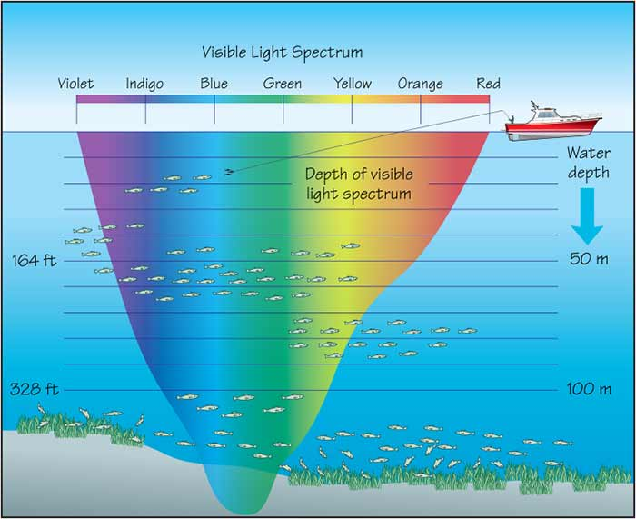
Light Color Depth
Color | Time in seconds

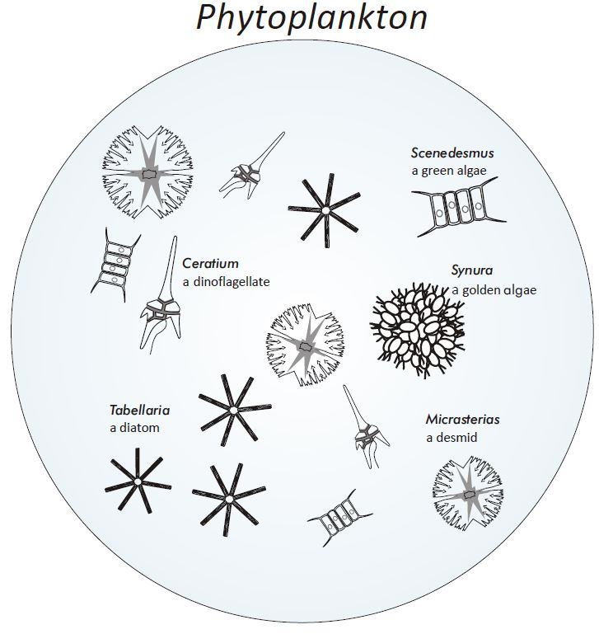

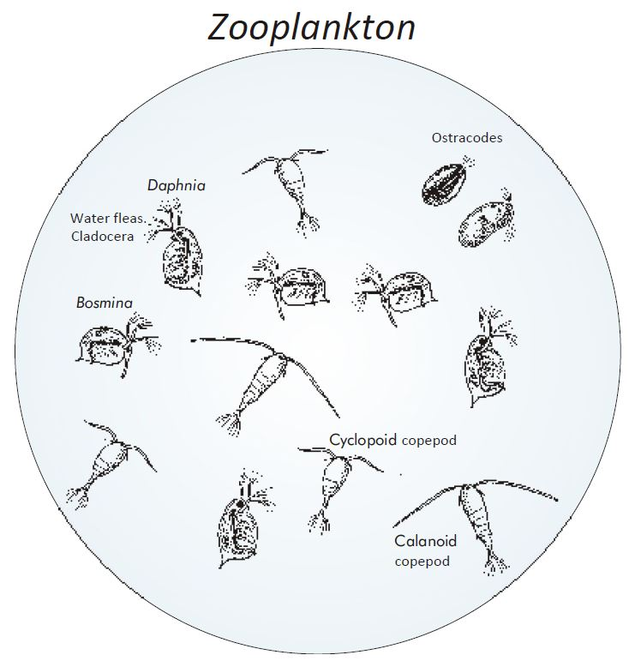

Guiding question: Why are harmful algal blooms (HABs) happening and what can my family do so we can all get in the water again (including our pets)?

What do you think so far… Look over your notes and the data you collected during this section and use this information to answer the “so far” questions below.
Section 2:  Plankton Collection | Explain what it is: | Explain how it could be related to the phenomenon:
Plankton

Phytoplankton

Carbon cycle

Section 2 Glossary:
Add the underlined terms found in the text Section 2 and complete the table below
Term | Illustration/key word | definition

Notes

